Auto-Scaling Local VM to Public Cloud
By
Harika Korivi (M25AI2132)

- Objective
The aim of this project is to create a local VM, monitor its CPU and memory usage, and automatically scale workloads to a public cloud (Google Cloud Platform) when resource utilization exceeds 75%. This ensures seamless application performance and efficient resource management.
Step-by-Step Implementation
Step 1: Creating the Local VM
- I created a local VM using VirtualBox running Ubuntu 22.04 LTS (Jammy Jellyfish).
- Allocated 2 vCPUs and 4GB RAM for testing purposes.
- Network adapter was configured as NAT for internet connectivity.
Step 2: Creating a Service Account in GCP
- I logged into Google Cloud Console and created a service account with permissions to:
  - Launch Compute Engine instances
  - Access and manage VM resources
- Generated a service account key (JSON) for authentication.
- This key was downloaded to my local machine and then transferred to the Ubuntu VM.
Step 3: Placing the Service Account Key
- The JSON key file was placed in the home directory of the VM:
/home/harika/vcc-assignment-488814-883cac623c68.json
- In the script, I set the environment variable:
export GOOGLE_APPLICATION_CREDENTIALS="$HOME/vcc-assignment-488814-883cac623c68.json"
- This allows the gcloud CLI to authenticate with GCP using the service account without manual login.
Step 4: Writing the Auto-Scale Script
- I wrote a single Bash script (auto_scale.sh) which:
  - Monitors CPU and memory usage using Linux commands (top and free).
  - Compares usage with thresholds (75% for CPU and memory).
  - If the threshold is exceeded, it triggers GCP Compute Engine to create a new VM instance.
Step 5: Running the Script
- Made the script executable:
chmod +x auto_scale.sh
- Ran it inside the Ubuntu VM:
./auto_scale.sh
- The script prints CPU and memory usage every 10 seconds (CHECK_INTERVAL) and launches a GCP VM when usage exceeds 75%.
Step 6: Deploying a Sample Application
- A simple text file was created in the startup script of the GCP VM to demonstrate deployment and remote execution:
echo "Hello from GCP VM!" > /home/ubuntu/message.txt
- This verifies that the VM is created and ready for further deployments.

2. Architecture Design
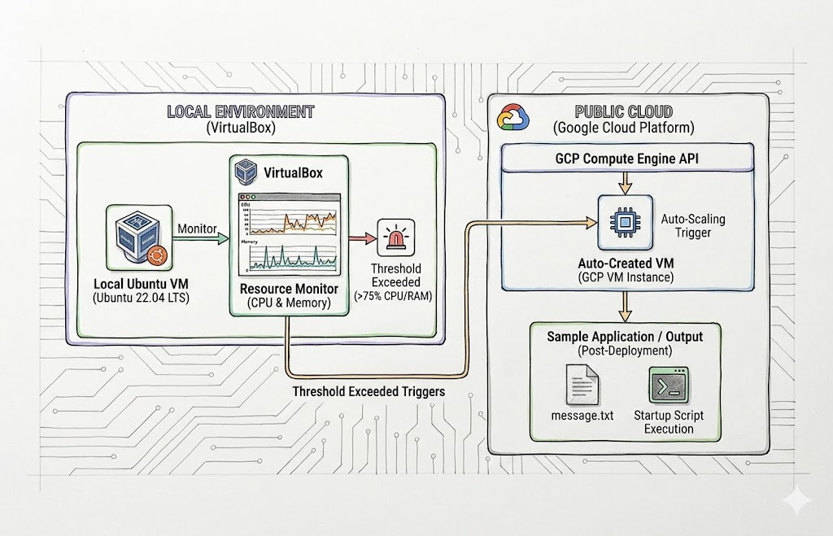
Explanation:
This architecture shows a hybrid cloud auto-scaling system that connects a local Ubuntu VM with Google Cloud to handle sudden spikes in workload. The local VM monitors its CPU and memory usage, and when it exceeds 75%, a script automatically triggers GCP to create a new cloud VM.
The newly created cloud VM runs a startup script to deploy a sample application or file, ensuring the workload is handled seamlessly. This approach keeps the system reliable, cost-efficient, and fully automated—only using cloud resources when the local VM is under high stress.
Conclusion:
In this project, we built a local Ubuntu VM that monitors its own CPU and memory usage and automatically scales to a Google Cloud VM when needed. Using a service account key and a simple script, the system can spin up cloud resources and deploy a sample application without any manual effort. This setup ensures the workload is handled smoothly, making it reliable, cost-efficient, and fully automated. Overall, it demonstrates how local and cloud environments can work together to manage resources effectively.

Git-hub Repository Link:
https://github.com/m25ai2132-ctrl/VCC-Assignment-3

Google Drive link:
https://drive.google.com/drive/folders/1u0HqX_eFuIM6snnn1Jicv9EiA0QVlfzH?usp=drive_link

